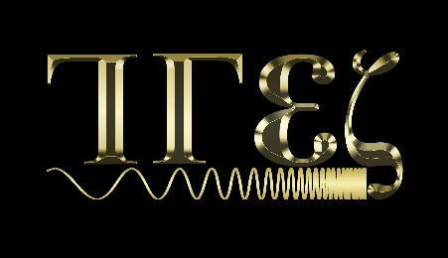 | TRANSACTIONS ON  ELECTROMAGNETIC  SPECTRUM
Copyright Form
Title of the paper:
_____________________________________________________________________________
_____________________________________________________________________________
The undersigned authors hereby agree that TRANSACTIONS ON ELECTROMAGNETIC SPECTRUM (TES JOURNAL) and Publisher “KAYHAN ÇELİK” have no responsibility over the content of the manuscript titled above.
The undersigned authors warrant that;
Originality of the Submission:
• The submitted manuscript (including the text, tables, figures, graphs, images, and any other related content) is original and has not been submitted to another journal for publication, has not been published before in whole or in part,
• If the manuscript has been published in whole or in part, all permissions were granted for publication in TES JOURNAL, and original copyright form and other required documents will be forwarded to TES JOURNAL.

Using Third Party Materials:
• The authors guarantee that the article does not infringe any personal or property right of others and accept the responsibility of the content of this manuscript and all other legal responsibilities related to the manuscript,
Copyright, License, and Rights:
• By signing this form, authors agree that the article, if accepted for publication by the TES JOURNAL, will be licensed under a Creative Commons Attribution-Non Commercial 4.0 International License (CC BY-NC) which allows third parties to share and adapt the material for only non- commercial purposes by giving the appropriate credit to the original work. For further details of the license CC BY-NC 4.0, please see https://creativecommons.org/licenses/by-nc/4.0/.
• The authors retain all patent and other proprietary rights to the article, including copyright.
• In addition to the non-exclusive rights the Publisher has under the CC BY-NC license, this agreement also authorizes the Publisher to permit the commercial use of the content.
Validity of the Agreement
• If the article is not accepted for publication in TES JOURNAL, the agreement will expire, and both the journal and the Publisher will not have any rights over the content.
This form should be signed by all authors and submitted during the initial submission with the rest of the manuscript files. The authors can either sign the same page or submit separately signed documents.
Author | Signature | Date of Signature

